**May 2019**

* Upload profile picture: error uploading file (both for .jpeg and .png) (the picture you see there was already there when I created a new profile. with each new profile created, it seems to randomly assign one of the pictures I uploaded in our earlier trials)
* 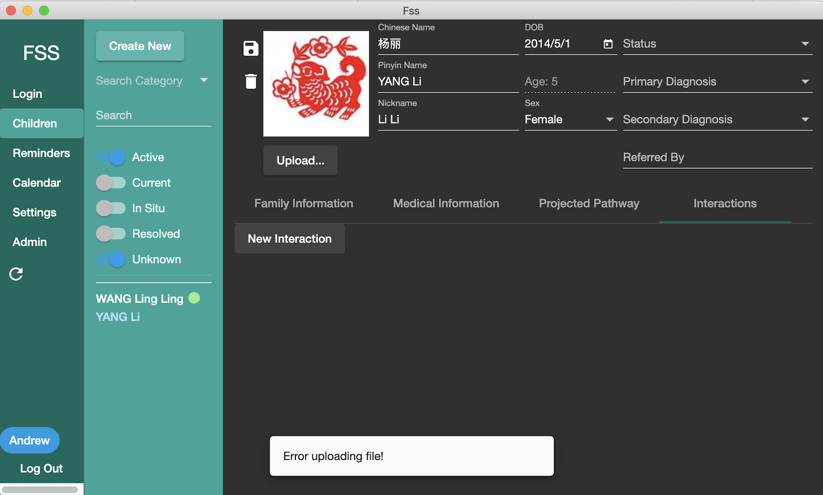Medical information: Upload file gives the same error as above (tried small .docx, .jpeg and .pdf). Not sure as I cannot test it, but it would be good if it would be possible to upload not just one document but as many as needed.
* 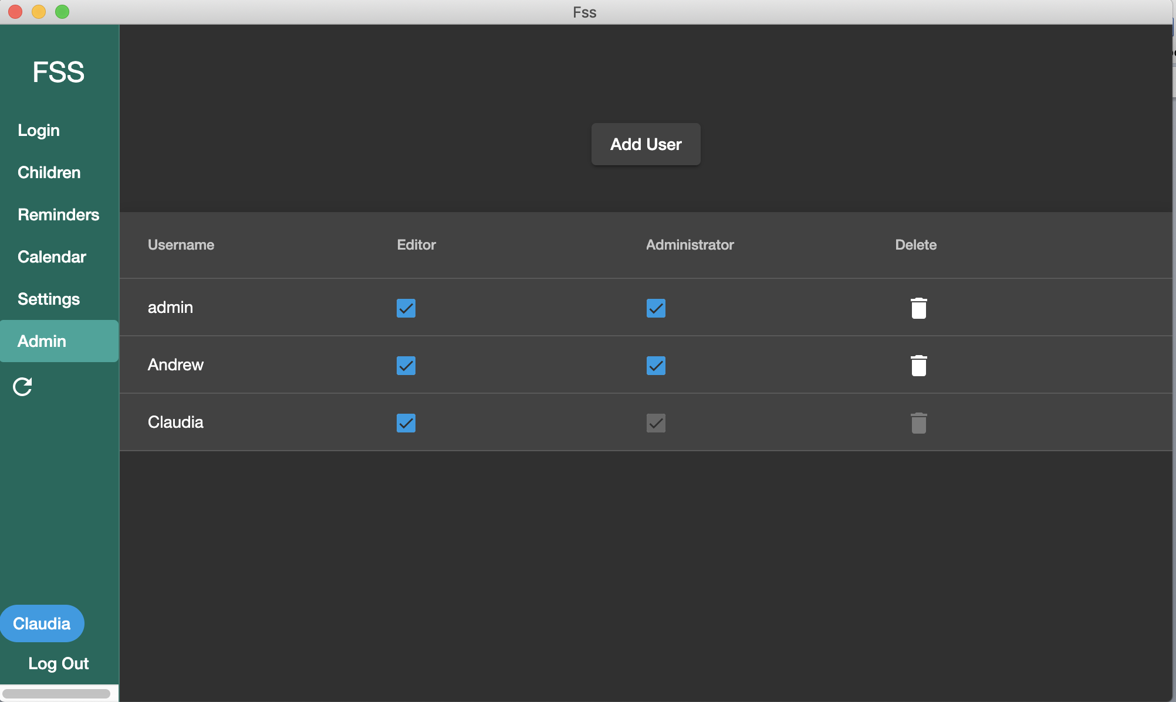I successfully added myself as a user and gave both editor and admin rights. However, it looks like any user could delete any other user (incl. the original admin)… That should probably only be possible for the admin, right?
* I would suggest that the default status for a newly created profile should be “active” (it’s “unknown” right now).

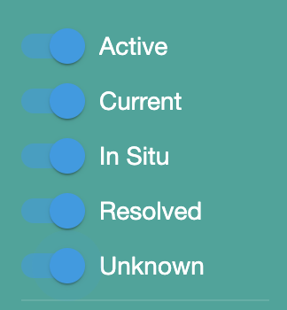

* Also, we’d like to be the default status view when entering the database should have all options on (see screen shot). It would be also helpful to have the colour dots behind each option (for easier reference for the children’s status)
* Calendar: Default view one month. Dates entered elsewhere should produce a dot on the calendar. If clicking on that date, there should be a full list of interactions/reminders etc. for that date.
* The reminder list needs to include the dates from the “projected pathways” (they will be set in the future as the date by which something needs to be completed).
* Currently, any date set for today (current date) will go to the reminder list. Maybe only include dates for the future? (but this is a small thing… If it’s too complicated, it’s really not worth spending too much time on it!)
* Medical Information: Needs a text field added at the bottom “Current Medical Status”
* Interactions: The long form should have a text field at the bottom for “Other”
* We talked about this in the beginning, but I just want to make sure: we (= me as the admin) need to be able to customize all the menus (it needs to be in Chinese in the end).
* …and there needs to be a way to print all that information…